UNIT 1
Introduction to materials, processes and technical skills in art and design

Name: Jack Oldham

Research
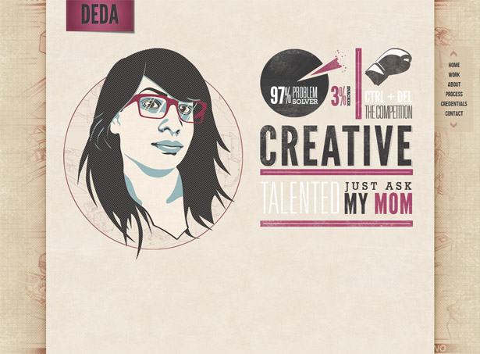

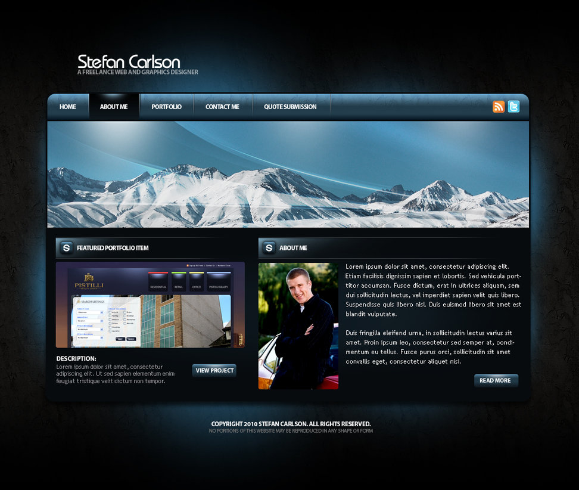

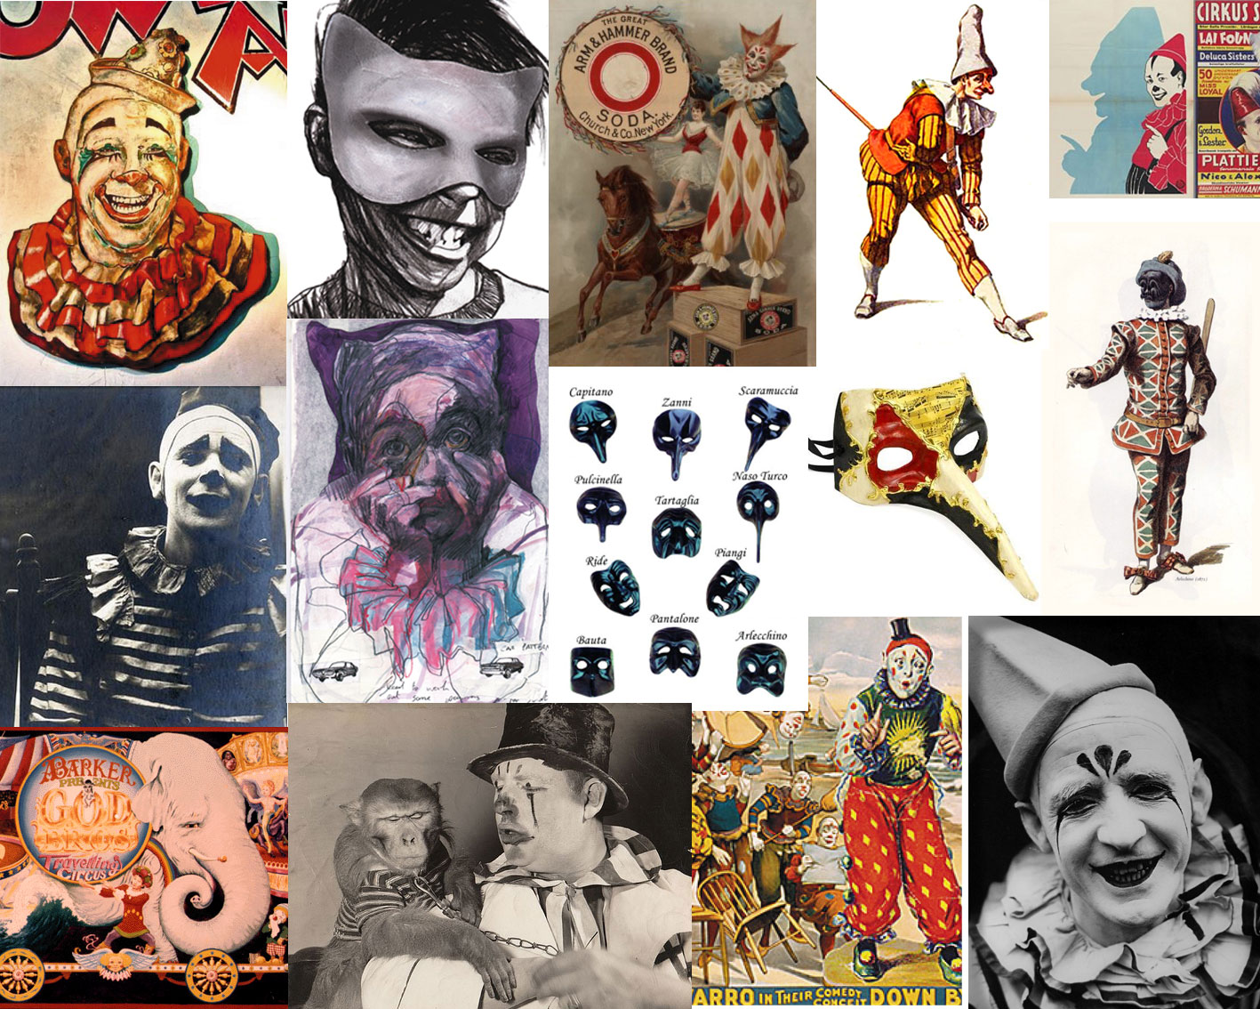

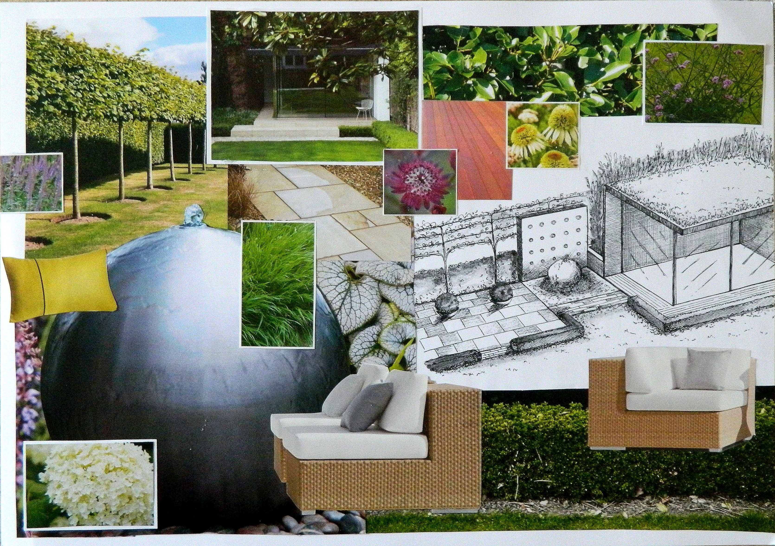

Moodboard

Use this page to show your inspiration for you eportfolio

SITE MAP

Fill out the site map and complete further using the correct site map format.

QR Code

Insert your QR code and explain what it is used for.

Screenshots of Website

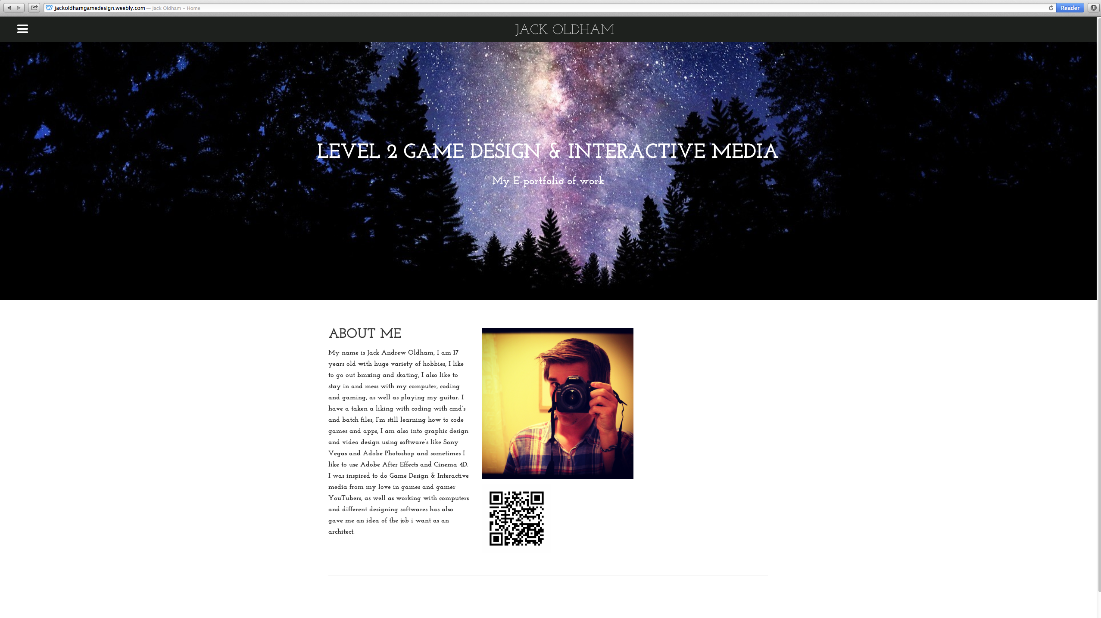

Screenshots of Website Continued

Evaluation
I have learnt to make a E-portfolio and how to set one up, as well as how to work them. I have also learnt how to use different masks in Adobe Photoshop and have learnt really quickly.

I have improved with my Photoshop skills and web design skills; I have been able to use different masks and different designs sets within Photoshop. I have also ben able to adapt onto my web design skills and understand it that be more then I did.

I have had a few issues / problems on the way and have managed to figure them and understand whats happened for example I have found that I need to stay on a set mac or always put my work on a memory stick otherwise if I go on a different mac I wont have my work on there any more.

I have solved it all that by re doing my work or moving it back over from one mac to the other using a memory stick and keeping it on a memory stick for future use or to show others like family or tutors.

